### **Customers Menu**

The Customers menu provides access to customer account management tools, and gives you the ability to see who is currently online in your store.

[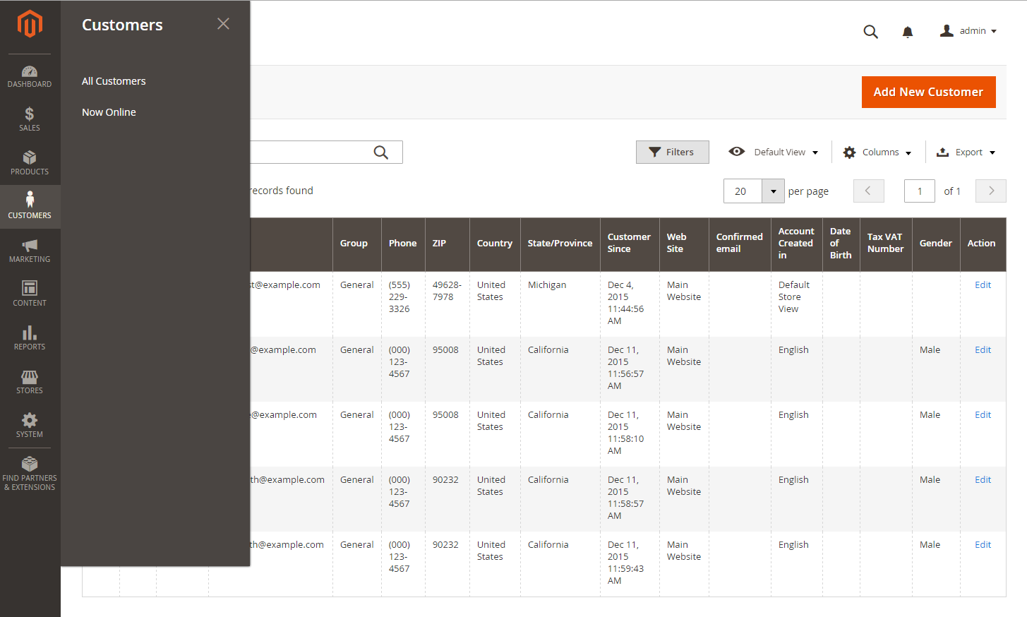](http://docs.magento.com/m2/ce/user_guide/Resources/Images/admin-menu-customers.png)  
  
**Customers Menu-**To display the Customers menu: **On the Admin sidebar, tap Customers.**

#### **Menu Options**

#### **All Customers**

The Customers grid lists all customers who have registered for an account with your store, or were added by the administrator. Use the standard grid controls to filter the list, and adjust the column layout. To learn more, see: Managing Customer Accounts.

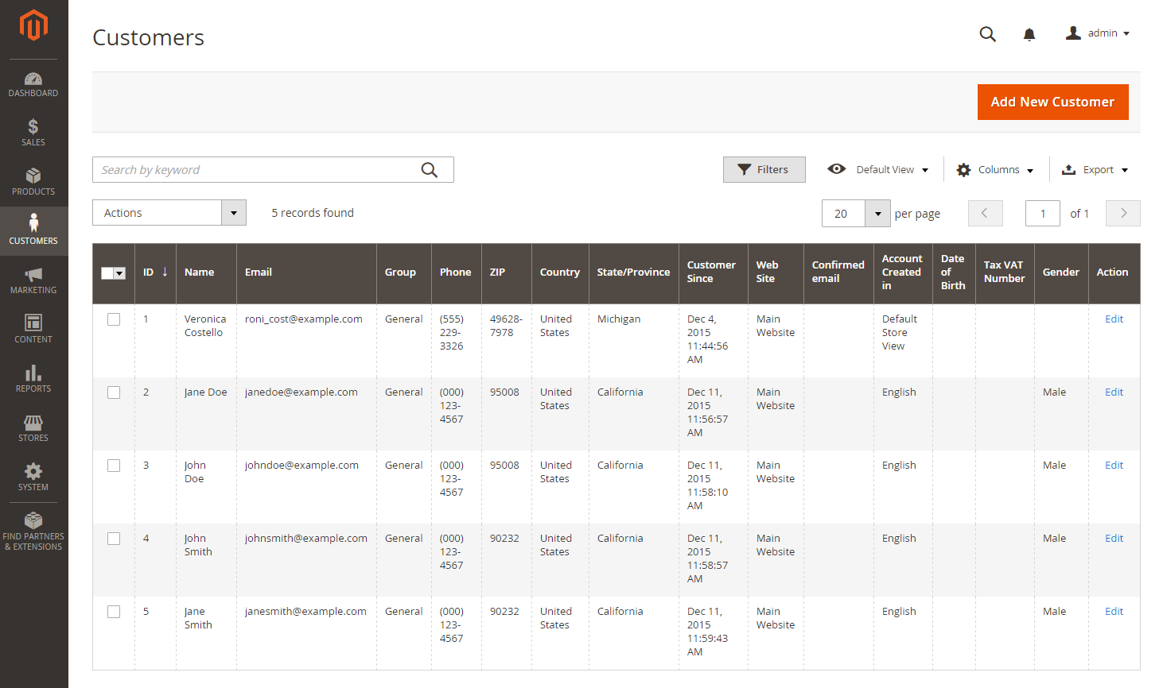

Lists all customers who have registered for an account with your store, or were added by the administrator.

To view customer information:

|  |  |  |
| --- | --- | --- |
|  | **1.** | On the Admin sidebar, tap **Customers**. Then, choose **All Customers**. |

|  |  |  |
| --- | --- | --- |
|  | **2.** | Find the customer record. Then in the Action column, click **Edit**. |

|  |  |  |
| --- | --- | --- |
|  | **3.** | In the panel on the left, choose the information you need to edit. Then, make the necessary changes. To learn more, see: Updating Customer Accounts. |

|  |  |  |
| --- | --- | --- |
|  | **4.** | When complete, tap  Save Customer . |

**2. Now Online**

The Now Online option on the Customers menu lists all customers and visitors who are currently online in your store. The interval of time that customers are shown as currently online is set in the configuration, and determines how long the customer’s activity is visible from the Admin. By default, the interval is fifteen minutes.

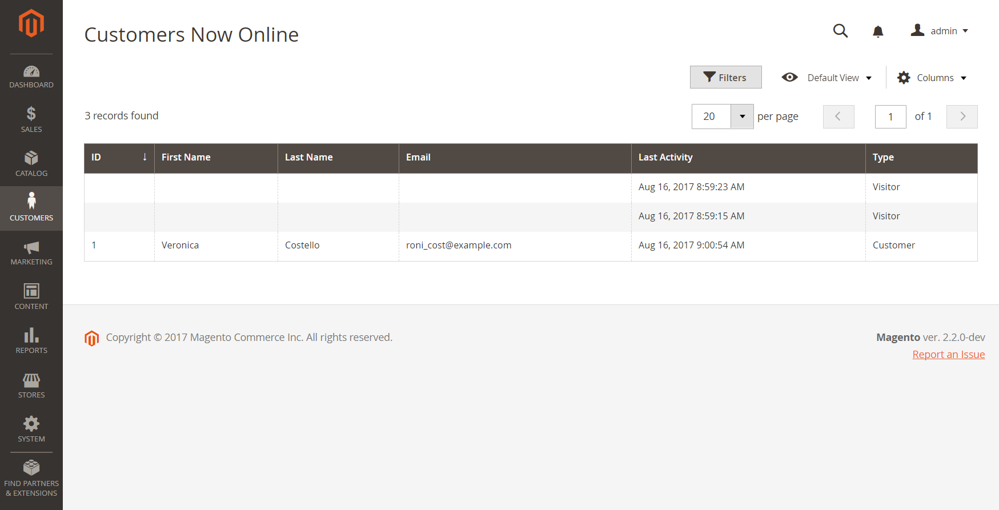

To see all customers who are online now:

|  |  |  |
| --- | --- | --- |
|  | **1.** | On the Admin sidebar, tap **Customers**. |

|  |  |  |
| --- | --- | --- |
|  | **2.** | Choose **Online Now**. |

To help an online customer complete a purchase, see: Shopping Assistance.

To configure the time interval:

|  |  |  |
| --- | --- | --- |
|  | **1.** | On the Admin sidebar, tap **Stores**. Then under **Settings**, choose **Configuration**. |

|  |  |  |
| --- | --- | --- |
|  | **2.** | In the panel on the left under **Customers**, choose **Customer Configuration**. |

|  |  |  |
| --- | --- | --- |
|  | **3.** | Expand http://docs.magento.com/m2/ce/user_guide/Resources/Images/btn-expand.pngthe **Online Customers Options** section. Then, do the following: |

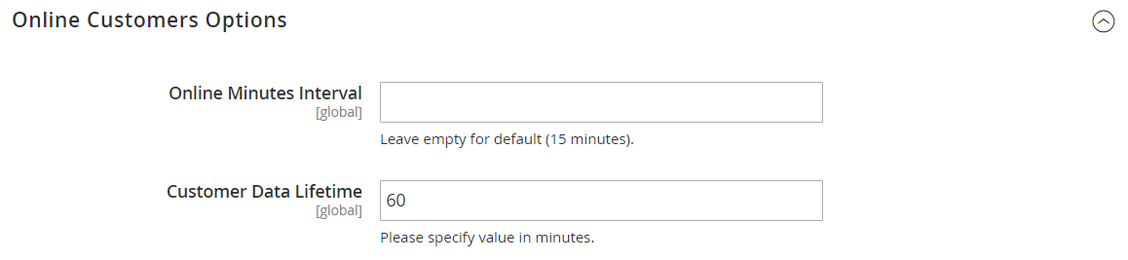

**a**. In the Online Minutes Interval field, enter the number of minutes for the customer session to be visible from the Admin. Leave the field empty to accept the default interval of fifteen minutes.

**b**. In the Customer Data Lifetime field, enter the number of minutes before any unsaved data entered by the customer expires.

|  |  |  |
| --- | --- | --- |
|  | **4.** | When complete, tap  Save Config . |

| Column Descriptions | |
| --- | --- |
| **Column** | **Description** |
| ID | The customer ID of a registered customer. |
| First Name | The first name of a registered customer. |
| Last Name | The last name of a registered customer. |
| Email | The email address of a registered customer. |
| IP Address | The IP address of the computer that customers and guests are using to access your store. |
| Session Start Time | The date and time that marks the beginning of the current customer session. |
| Last Activity | The date and time of the customer’s last activity in your store. |
| Type | Options include: Customer / Visitor |
| Last URL | The last URL the customer visited. |

### **Customer Accounts**

The header of every page in your store extends an invitation for shoppers to “Log in or register” for an account with your store. Customers who open an account enjoy a range of benefits, including:

|  |  |
| --- | --- |
| http://docs.magento.com/m2/ce/user_guide/Resources/Images/assets/checkbox.png | **Faster checkout.** Registered customers move through checkout faster because much of the information is already in their accounts. |
| http://docs.magento.com/m2/ce/user_guide/Resources/Images/assets/checkbox.png | **Self service.** Registered customers can update their information, check the status of orders, and even reorder from their account dashboard. |

Customers can access their account dashboard by clicking the “My Account” link in the header of the store. They can use their account dashboard to view and modify their information, including past and current addresses, billing and shipping preferences, newsletter subscriptions, wishlist, and more.

[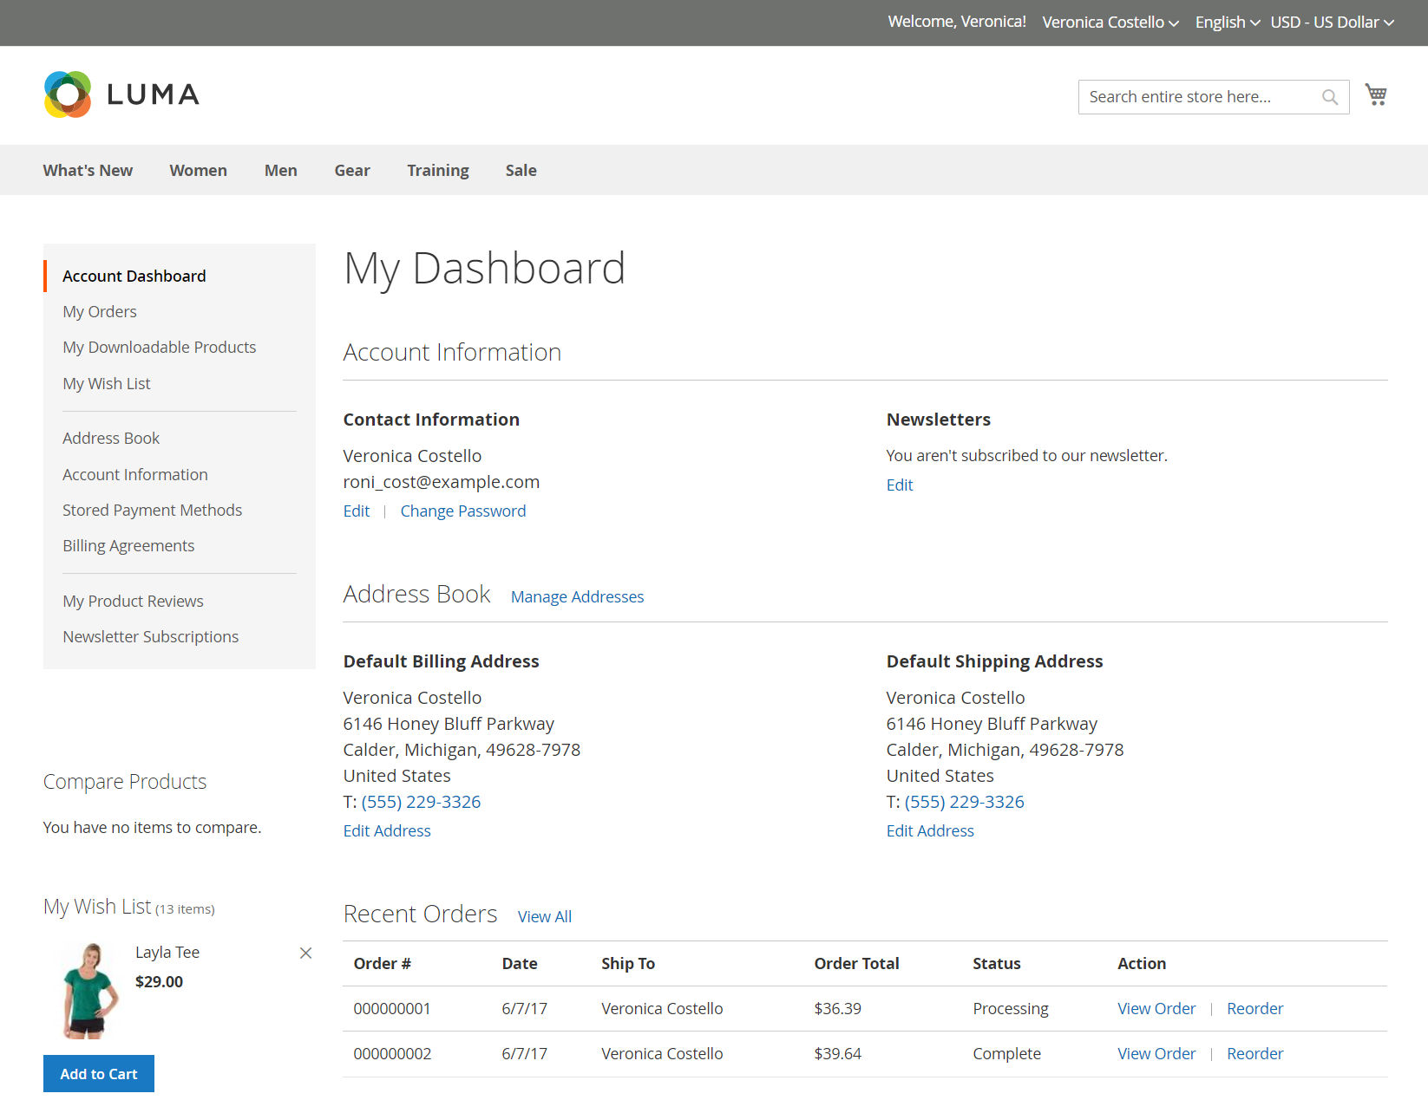](http://docs.magento.com/m2/ce/user_guide/Resources/Images/customer-dashboard.png)

#### **Configuring Account Options**

The customer account settings determine the information that is collected during customer registration, and the experience that customers have during the process. Customer configuration settings include:

1. [**Account Scope**](http://docs.magento.com/m2/ce/user_guide/customers/account-scope.html)
2. [**Login Landing Page**](http://docs.magento.com/m2/ce/user_guide/customers/login-landing-page.html)
3. [**New Account Options**](http://docs.magento.com/m2/ce/user_guide/customers/account-options-new.html)
4. [**Name and Address Options**](http://docs.magento.com/m2/ce/user_guide/customers/name-address-options.html)
5. [**Password Options**](http://docs.magento.com/m2/ce/user_guide/customers/password-options.html)
6. [**Customer Session Lifetime**](http://docs.magento.com/m2/ce/user_guide/customers/customer-online-options.html)

[**Account Scope**](http://docs.magento.com/m2/ce/user_guide/customers/account-scope.html)

To set the scope of customer accounts:

|  |  |  |
| --- | --- | --- |
|  | **1.** | On the Admin sidebar, tap **Stores**. Then under **Settings**, choose **Configuration**. |

|  |  |  |
| --- | --- | --- |
|  | **2.** | In the panel on the left, under **Customers**, choose **Customer Configuration**. |

|  |  |  |
| --- | --- | --- |
|  | **3.** | Expand http://docs.magento.com/m2/ce/user_guide/Resources/Images/btn-expand.pngthe **Account Sharing Options** section. |

[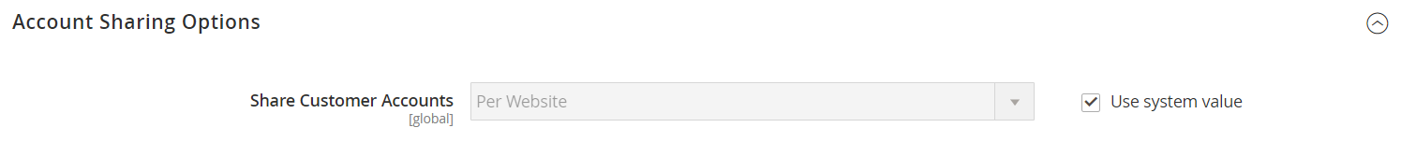](http://docs.magento.com/m2/ce/user_guide/Resources/Images/config-customers-customer-configuration-account-sharing-options.png)  
[Account Sharing Options](http://docs.magento.com/m2/ce/user_guide/configuration/customers/customer-configuration.html#AccountSharingOptions)

|  |  |  |
| --- | --- | --- |
|  | **4.** | If necessary, clear the **User system value** checkbox. Then, set **Share Customer Accounts** to one of the following: |

|  |  |
| --- | --- |
| Global | Shares customer account information with every website and store in the Magento installation. |
| Per Website | Limits customer account information to the website where the account was created. |

|  |  |  |
| --- | --- | --- |
|  | **5.** | When complete, tap Save Config. |

[**Login Landing Page**](http://docs.magento.com/m2/ce/user_guide/customers/login-landing-page.html)

To set the [login](javascript:void(0);) [landing page](javascript:void(0);):

|  |  |  |
| --- | --- | --- |
|  | **1.** | On the Admin sidebar, tap **Stores**. Then under **Settings**, choose **Configuration**. |

|  |  |  |
| --- | --- | --- |
|  | **2.** | In the panel on the left, under **Customers**, choose **Customer Configuration**. |

|  |  |  |
| --- | --- | --- |
|  | **3.** | Expand http://docs.magento.com/m2/ce/user_guide/Resources/Images/btn-expand.pngthe **Login Options** section. |

[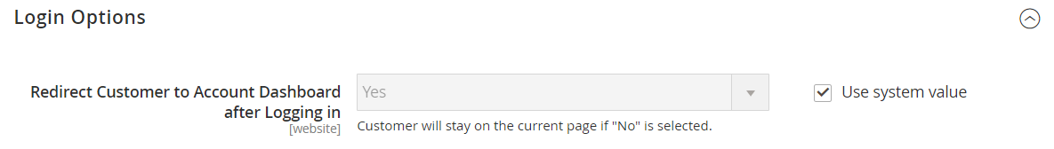](http://docs.magento.com/m2/ce/user_guide/Resources/Images/config-customers-customer-configuration-login-options.png)  
Login Options

|  |  |  |
| --- | --- | --- |
|  | **4.** | Set **Redirect Customer to Account Dashboard after Logging in** to one of the following: |

|  |  |
| --- | --- |
| Yes | The account dashboard appears when customers log in to their accounts. |
| No | Customers can continue shopping after logging in to their accounts. |

|  |  |  |
| --- | --- | --- |
|  | **5.** | When complete, tap Save Config. |

[**New Account Options**](http://docs.magento.com/m2/ce/user_guide/customers/account-options-new.html)

In the Create New Account Options section of the configuration, the basic account options are combined with more advanced options that relate to VAT ID Validation and custom integrations. The following instructions cover only the most frequently used options. To learn about automatic customer group assignments, see: VAT ID Validation.

[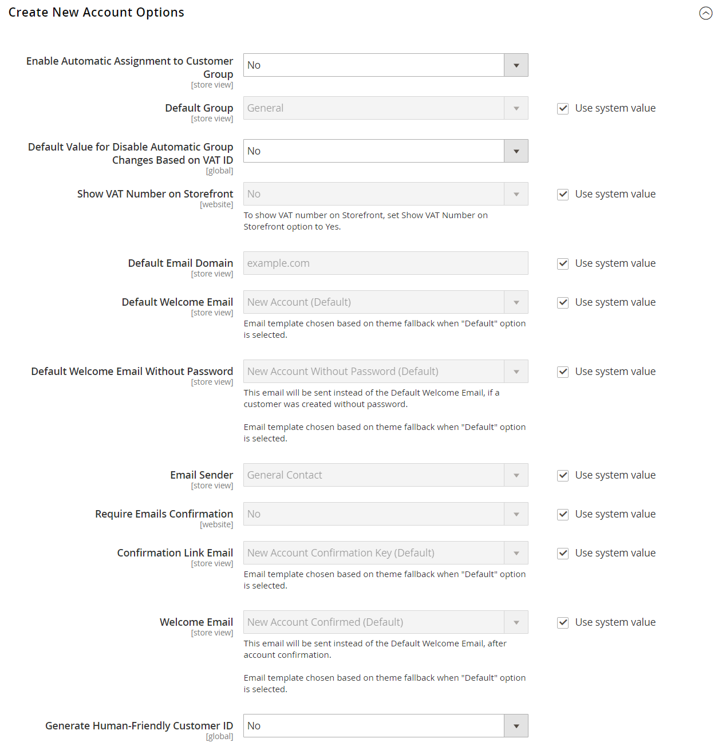](http://docs.magento.com/m2/ce/user_guide/Resources/Images/config-customers-customer-configuration-create-new-account-options.png)  
Create New Account Options

To set up the basic customer account options:

|  |  |  |
| --- | --- | --- |
|  | **1.** | On the Admin sidebar, tap **Stores**. Then under **Settings**, choose **Configuration**. |

|  |  |  |
| --- | --- | --- |
|  | **2.** | In the panel on the left under **Customers**, choose **Customer Configuration**. |

|  |  |  |
| --- | --- | --- |
|  | **3.** | Expand http://docs.magento.com/m2/ce/user_guide/Resources/Images/btn-expand.pngthe **Create New Account Options** section. Then, do the following: |

|  |  |  |
| --- | --- | --- |
|  | **a.** | Set **Default Group** to the customer group that is assigned to new customers when an account is created. |

|  |  |  |
| --- | --- | --- |
|  | **a.** | If you have a Value Added Tax number, and want it to be visible to customers, set **Show VAT Number on Storefront** to “Yes.” |

|  |  |  |
| --- | --- | --- |
|  | **b.** | Enter the **Default Email Domain** for the store. For example: mystore.com |

|  |  |  |
| --- | --- | --- |
|  | **c.** | Set **Default Welcome Email** to the template that is used for the Welcome email sent to new customers. |

|  |  |  |
| --- | --- | --- |
|  | **d.** | Set **Default Welcome Email without Password** to the template that is used when a customer account is created that does not yet have a password. For example, a customer account created from the Admin does not yet have a password assigned. |

|  |  |  |
| --- | --- | --- |
|  | **e.** | Set **Email Sender** to the store contact that appears as the sender of the Welcome email. |

|  |  |  |
| --- | --- | --- |
|  | **f.** | To require that customers confirm their request to open an account with your store, set **Require Emails Confirmation** to “Yes.” Then, set **Confirmation Link Email** to the template that is used for the confirmation email. |

|  |  |  |
| --- | --- | --- |
|  | **g.** | Set **Welcome Email** to the template that is used for the Welcome message that is sent after the account is confirmed. |

|  |  |  |
| --- | --- | --- |
|  | **4.** | When complete, tap Save Config. |

[**Name and Address Options**](http://docs.magento.com/m2/ce/user_guide/customers/name-address-options.html)

The Name and Address Options determine the values in the drop-down lists for the prefix and suffix part of the customer name.

To configure the customer name and address:

|  |  |  |
| --- | --- | --- |
|  | **1.** | On the Admin sidebar, tap **Stores**. Then under **Settings**, choose **Configuration**. |

|  |  |  |
| --- | --- | --- |
|  | **2.** | In the panel on the left, under **Customers**, choose **Customer Configuration**. |

|  |  |  |
| --- | --- | --- |
|  | **3.** | Expand http://docs.magento.com/m2/ce/user_guide/Resources/Images/btn-expand.pngthe **Name and Address Options** section. |

[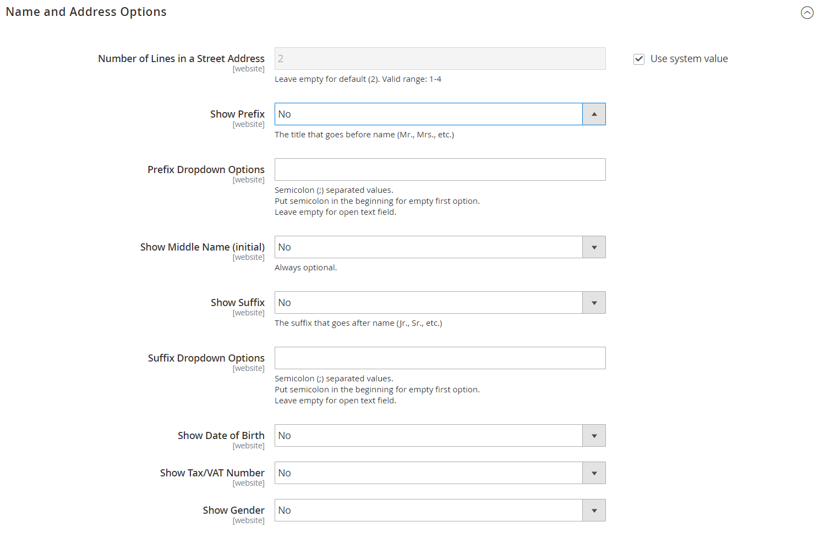](http://docs.magento.com/m2/ce/user_guide/Resources/Images/config-customers-customer-configuration-name-address.png)

Name and Address Options

|  |  |  |
| --- | --- | --- |
|  | **1.** | Enter the **Number of Lines in a Street Address**. If left blank, the street address defaults to 2. |

|  |  |  |
| --- | --- | --- |
|  | **2.** | To include a prefix before the name, do the following: |

|  |  |  |
| --- | --- | --- |
|  | **a.** | Set **Show Prefix** to one of the following: |

* Optional
* Required

|  |  |  |
| --- | --- | --- |
|  | **b.** | In the **Prefix Dropdown Options** field, enter each prefix that you want to appear in the list, separated by a semicolon. Place a semicolon before the first value to display an empty value at the top of the list. |

|  |  |  |
| --- | --- | --- |
|  | **3.** | To include a suffix after the name, do the following: |

|  |  |  |
| --- | --- | --- |
|  | **a.** | Set **Show Suffix** to one of the following: |

* Optional
* Required

|  |  |  |
| --- | --- | --- |
|  | **b.** | In the **Suffix Dropdown Options** field, enter each prefix that you want to appear in the list, separated by a semicolon. Place a semicolon before the first value to display an empty value at the top of the list. |

|  |  |  |
| --- | --- | --- |
|  | **4.** | To include additional fields, do the following: |

|  |  |  |
| --- | --- | --- |
|  | **a.** | Set **Show Date of Birth** to “Yes.” |

|  |  |  |
| --- | --- | --- |
|  | **b.** | Set **Show Tax/VAT Number** to “Yes.” |

|  |  |  |
| --- | --- | --- |
|  | **c.** | Set **Show Gender** to “Yes.” |

|  |  |  |
| --- | --- | --- |
|  | **5.** | When complete, tap Save Config. |

[**Password Options**](http://docs.magento.com/m2/ce/user_guide/customers/password-options.html)

The customer password options control the level of security that is used for password reset requests, and determines the email templates that are used for customer notification, and the lifetime of the password recovery link. You can allow customers to change their own passwords, or require that only store administrators can do so

To configure customer password options:

|  |  |  |
| --- | --- | --- |
|  | **1.** | On the Admin sidebar, tap **Stores**. Then under **Settings**, choose **Configuration**. |

|  |  |  |
| --- | --- | --- |
|  | **2.** | In the panel on the left under **Customers**, choose **Customer Configuration**. Then, expand http://docs.magento.com/m2/ce/user_guide/Resources/Images/btn-expand.pngthe **Password Options** section. |

[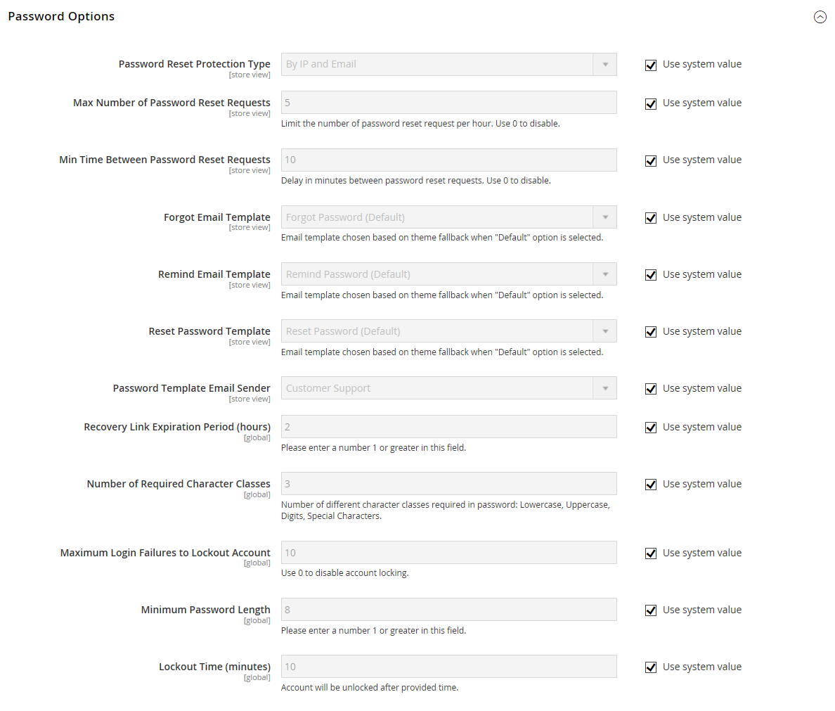](http://docs.magento.com/m2/ce/user_guide/Resources/Images/config-customers-customer-configuration-password-options.png)

[**Password Options**](http://docs.magento.com/m2/ce/user_guide/configuration/customers/customer-configuration.html#PasswordOptions)

|  |  |  |
| --- | --- | --- |
|  | **3.** | Set **Password Reset Protection Type** to the method you want to use for managing password reset requests: |

|  |  |
| --- | --- |
| By IP and Email | The password can be reset online after a response is received from a reset notification sent to the email address associated with the Admin account. |
| By IP | The password can be reset online without additional confirmation. |
| By Email | The password can be reset only by responding to an email notification that is sent to the email address associated with the Admin account. |
| None | The password can be reset only by the store administrator. |

|  |  |  |
| --- | --- | --- |
|  | **4.** | To limit the number of password reset requests sent per hour, do the following: |

|  |  |  |
| --- | --- | --- |
|  | **a.** | In the **Max Number of Password Reset Requests** field, enter the maximum number of password reset requests that can be sent per hour. |

|  |  |  |
| --- | --- | --- |
|  | **b.** | In the **Min Time Between Password Reset Requests** field, enter the minimum number of minutes that must elapse between requests. |

|  |  |  |
| --- | --- | --- |
|  | **5.** | To configure the password reset email notification, do the following: |

|  |  |  |
| --- | --- | --- |
|  | **a.** | Set **Forgot Email Template** to the template that is used for the email sent to customers who have forgotten their passwords. |

|  |  |  |
| --- | --- | --- |
|  | **b.** | Set **Remind Email Template** to the template that is used when a password hint is sent to customers. |

|  |  |  |
| --- | --- | --- |
|  | **c.** | Set **Reset Password Template** to the template that is used when customers change their passwords. |

|  |  |  |
| --- | --- | --- |
|  | **d.** | Set **Password Template Email Sender** to the [store contact](http://docs.magento.com/m2/ce/user_guide/stores/store-email-addresses.html) that appears as the sender of password-related notifications. |

|  |  |  |
| --- | --- | --- |
|  | **6.** | Complete the following password reset security options: |

|  |  |  |
| --- | --- | --- |
|  | **a.** | In the **Recovery Link Expiration Period (hours)** field, enter the number of hours before the password recovery link expires. |

|  |  |  |
| --- | --- | --- |
|  | **b.** | In the **Number of Required Character Classes** field, enter the number of different character types that must be included in a password, based on the following character classes: |

* Lowercase
* Uppercase
* Numeric
* Special Characters

|  |  |  |
| --- | --- | --- |
|  | **c.** | In the **Maximum Login  Failures to Lockout Account** field, enter the number of failed login attempts until the Admin account is locked. For unlimited attempts, enter zero (0). |

|  |  |  |
| --- | --- | --- |
|  | **d.** | In the **Minimum Password Length** field, enter the minimum number of characters that can be used in a password. The number must be greater than zero. |

|  |  |  |
| --- | --- | --- |
|  | **e.** | In the **Lockout Time (minutes)** field, enter the number of minutes an Admin account is locked after too many failed attempts to log in. |

|  |  |  |
| --- | --- | --- |
|  | **7.** | When complete, tap Save Config. |

[**Customer Session Lifetime**](http://docs.magento.com/m2/ce/user_guide/customers/customer-online-options.html)

The lifetime of a customer shopping session is determined by several factors, including the length of the server session, the use of a [persistent cart](http://docs.magento.com/m2/ce/user_guide/sales/cart-persistent.html), and the lifetime of information that is stored in the browser. Although these are related to the same customer experience, they are actually separate processes with different expiration events and lifetimes.

|  |  |
| --- | --- |
| Session | Information that is stored on the server, such as the contents of the [shopping cart](javascript:void(0);). If the server session expires before the cookie expires, customers might lose the cart contents and reduce security risk. |
| Session Cookie | Information that is stored in the browser as a number or string of characters. If the session cookie expires before the server session, the customer is logged out. The session cookie is deleted when the customer closes the browser window. By default, the cookie lifetime is set to 3600 seconds, or one hour. If there is no keyboard activity during that time, the current session ends, and customers must log back into their accounts to continue shopping. |

If [Persistent Cart](http://docs.magento.com/m2/ce/user_guide/sales/cart-persistent.html) is enabled, the cart contents are saved for the next time customers sign into their accounts. When using a persistent cart, it is recommended that you set the lifetime of the server session and the session cookie to a long period of time.

On the server, the length of the session is controlled by php.ini, and several variables. At this time, Magento does not have an [Admin](javascript:void(0);) configuration setting that controls the length of the server session.

To configure the cookie lifetime:

|  |  |  |
| --- | --- | --- |
|  | **1.** | On the Admin sidebar, tap **Stores**. Then under **Settings**, choose **Configuration**. |

|  |  |  |
| --- | --- | --- |
|  | **2.** | If you have multiple stores, set the **Store View** chooser in the upper-right corner to the store where the configuration applies. |

|  |  |  |
| --- | --- | --- |
|  | **3.** | In the panel on the left under **General**, choose **Web**. |

|  |  |  |
| --- | --- | --- |
|  | **4.** | Expand http://docs.magento.com/m2/ce/user_guide/Resources/Images/btn-expand.pngthe **Default Cookie Settings** section. |

[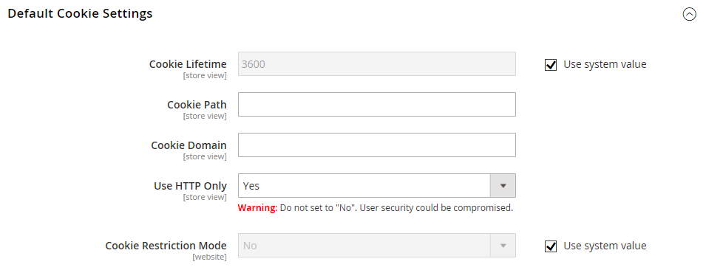](http://docs.magento.com/m2/ce/user_guide/Resources/Images/config-general-web-default-cookie-settings.png)  
Default Cookie Settings

|  |  |  |
| --- | --- | --- |
|  | **5.** | To change the default, clear the **Use system value** checkbox. Then, enter the new value in seconds. |

|  |  |  |
| --- | --- | --- |
|  | **6.** | Tap Save Config. |

#### Creating an Account

Visitors to your store can open an account to manage their purchases and activities. Customers usually create their own accounts from your store. However, you can also create customer accounts directly from the [Admin](javascript:void(0);), which is useful for helping customers over the phone.

The following instructions represent the default customer account configuration. To change the selection and behavior of some of the fields in the form, see: [Configuring Account Options](http://docs.magento.com/m2/ce/user_guide/customers/customer-account-configuration.html).

[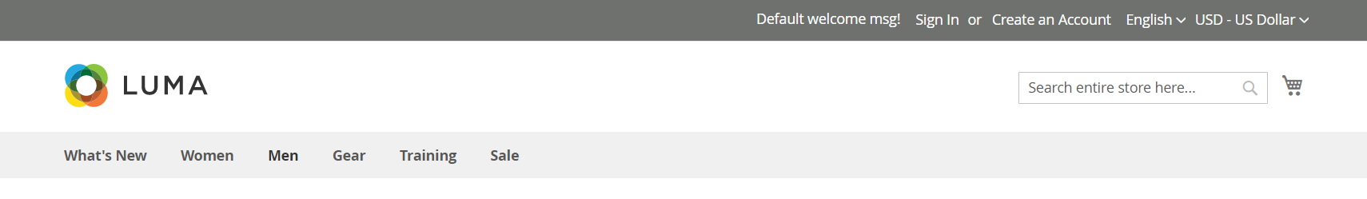](http://docs.magento.com/m2/ce/user_guide/Resources/Images/storefront-create-an-account-link.png)  
  
  
Create an Account

[[Open](javascript:void(0);)**Method 1:** Create Account from Storefront](javascript:void(0);)

|  |  |  |
| --- | --- | --- |
|  | **1.** | From the storefront, click the **Create an Account** link in the upper-right corner of the header. |

|  |  |  |
| --- | --- | --- |
|  | **2.** | Under **Personal Information**, enter your **First Name** and **Last Name**. |

[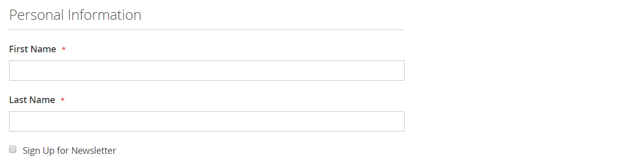](http://docs.magento.com/m2/ce/user_guide/Resources/Images/storefront-create-account-personal-information.png)  
Personal Information

|  |  |  |
| --- | --- | --- |
|  | **3.** | If you want to add your name and email address to the list of newsletter subscribers, mark the **Sign Up for Newsletter** checkbox. |

This option appears even if the store doesn’t publish a newsletter.

|  |  |  |
| --- | --- | --- |
|  | **4.** | Under **Sign-in Information**, enter your **Email** address. |

This email address will become part of your sign-in credentials, and cannot be associated with any other customer account.

[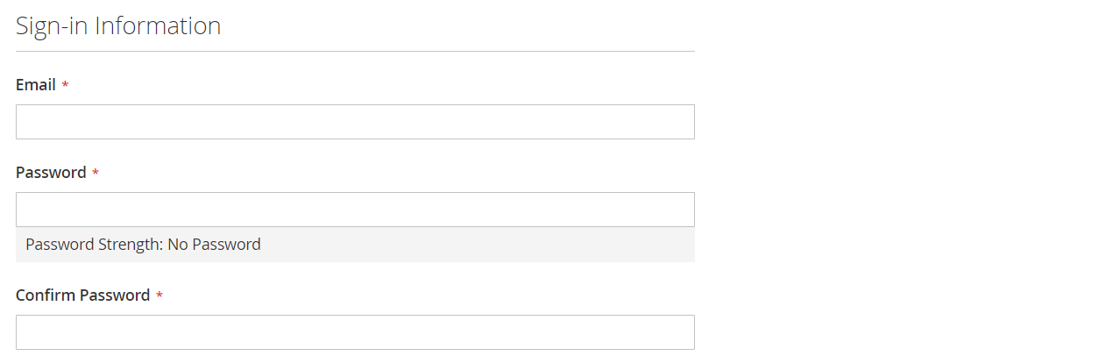](http://docs.magento.com/m2/ce/user_guide/Resources/Images/storefront-create-account-signin-information.png)  
Sign-in Information

|  |  |  |
| --- | --- | --- |
|  | **5.** | Enter a **Password** that includes three of the following types of information: |

* Lowercase characters
* Uppercase characters
* Numbers
* Special Characters

After you press **Enter**, the strength of the password is evaluated, and appears below the field. If the password is considered to be “Weak,” try another until it evaluated as “Strong”.

[](http://docs.magento.com/m2/ce/user_guide/Resources/Images/storefront-customer-account-create-password-strong.png)

Then, enter it again to **Confirm Password**.

|  |  |  |
| --- | --- | --- |
|  | **6.** | When complete, tap Create an Account. |

You can now use your email address and password to [sign in](http://docs.magento.com/m2/ce/user_guide/stores/admin-signin.html) to your account to complete the address information.

[[Closed](javascript:void(0);)**Method 2:** Create Account from Admin](javascript:void(0);)

### Customer Groups

Customer groups determine which discounts are available, and the tax class that is associated with the group. The default customer groups are General, Not Logged In, and Wholesale.

[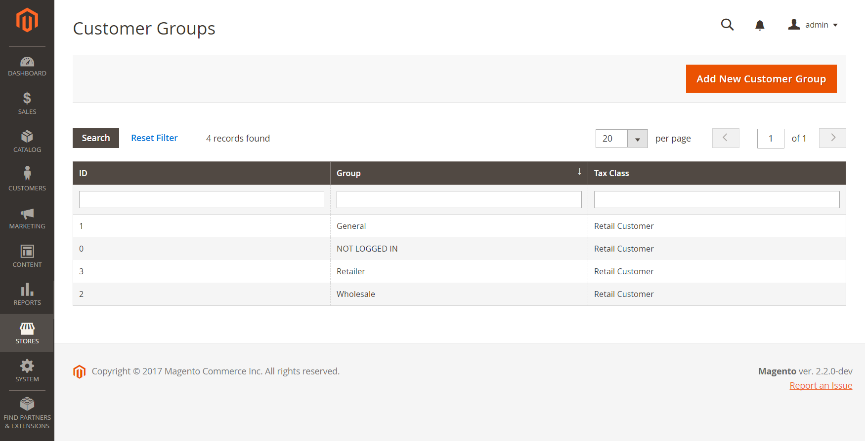](http://docs.magento.com/m2/ce/user_guide/Resources/Images/customer-groups.png)  
Customer Groups

[[Open](javascript:void(0);)To create a customer group:](javascript:void(0);)

|  |  |  |
| --- | --- | --- |
|  | **1.** | On the Admin sidebar, tap **Stores**. Then under **Other Settings**, choose **Customer Groups**. |

|  |  |  |
| --- | --- | --- |
|  | **2.** | Tap  Add New Customer Group . Then, do the following: |

|  |  |  |
| --- | --- | --- |
|  | **a.** | Enter a unique **Group Name** less than 32 characters to identify the group. |

|  |  |  |
| --- | --- | --- |
|  | **b.** | Select the **Tax Class** that applies to the group. |

[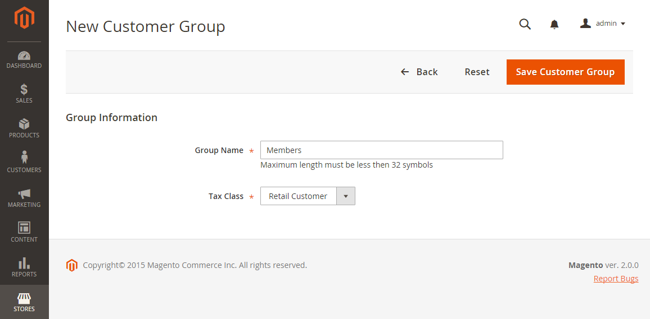](http://docs.magento.com/m2/ce/user_guide/Resources/Images/stores-customer-group-information.png)  
Group Information

|  |  |  |
| --- | --- | --- |
|  | **3.** | When complete, tap  Save Customer Group . |

[[Open](javascript:void(0);)To edit a customer group:](javascript:void(0);)

|  |  |  |
| --- | --- | --- |
|  | **1.** | On the Admin sidebar, tap **Stores**. Then under **Other Settings**, choose **Customer Groups**. |

|  |  |  |
| --- | --- | --- |
|  | **2.** | Open the record in edit mode. |

|  |  |  |
| --- | --- | --- |
|  | **3.** | Make the necessary changes. |

|  |  |  |
| --- | --- | --- |
|  | **4.** | When complete, tap  Save Customer Group . |

[[Open](javascript:void(0);)To assign a customer to a different group:](javascript:void(0);)

|  |  |  |
| --- | --- | --- |
|  | **1.** | On the Admin sidebar, tap **Customers**. Then, choose **All Customers**. |

|  |  |  |
| --- | --- | --- |
|  | **2.** | Find the customer in the list, and mark the checkbox in the first column. Then, do the following: |

|  |  |  |
| --- | --- | --- |
|  | **a.** | Set the **Actions** control to “Assign a Customer Group.” |

|  |  |  |
| --- | --- | --- |
|  | **b.** | Set the **Group** control to the new group. |

|  |  |  |
| --- | --- | --- |
|  | **c.** | When prompted to confirm, tap  OK . |

[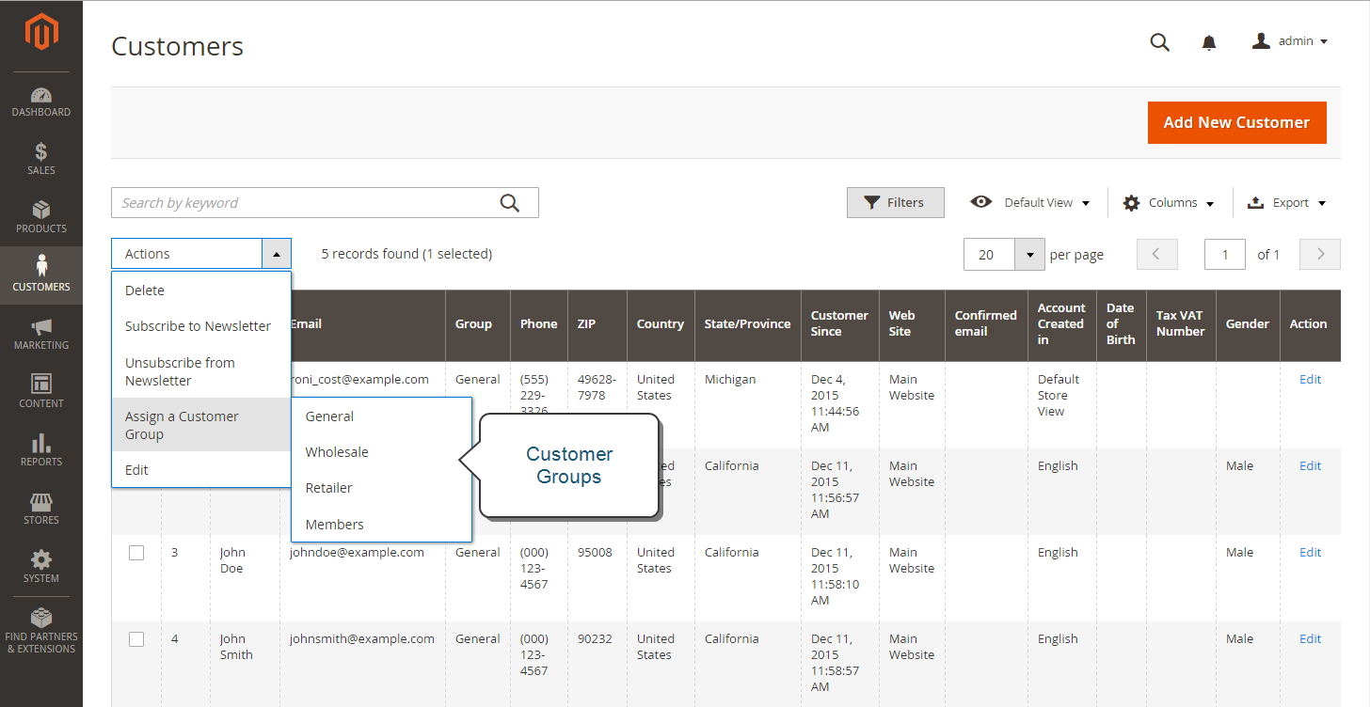](http://docs.magento.com/m2/ce/user_guide/Resources/Images/stores-customer-group-assign.png)  
Assign a Customer Group

[[Open](javascript:void(0);)To delete a customer group:](javascript:void(0);)

|  |  |  |
| --- | --- | --- |
|  | **1.** | On the Admin sidebar, tap **Stores**. Then under **Other Settings**, choose **Customer Groups**. |

|  |  |  |
| --- | --- | --- |
|  | **2.** | Open the record in edit mode. |

|  |  |  |
| --- | --- | --- |
|  | **3.** | In the button bar, tap **Delete Customer Group**. |

|  |  |  |
| --- | --- | --- |
|  | **4.** | When prompted to confirm, tap OK. |

|  |  |  |
| --- | --- | --- |
|  | **5.** | When complete, tap  Save Customer Group . |

### **Customer Groups**

Customer groups determine which discounts are available, and the tax class that is associated with the group. The default customer groups are General, Not Logged In, and Wholesale.

[](http://docs.magento.com/m2/ce/user_guide/Resources/Images/customer-groups.png)  
Customer Groups

[[Open](javascript:void(0);)To create a customer group:](javascript:void(0);)

|  |  |  |
| --- | --- | --- |
|  | **1.** | On the Admin sidebar, tap **Stores**. Then under **Other Settings**, choose **Customer Groups**. |

|  |  |  |
| --- | --- | --- |
|  | **2.** | Tap  Add New Customer Group . Then, do the following: |

|  |  |  |
| --- | --- | --- |
|  | **a.** | Enter a unique **Group Name** less than 32 characters to identify the group. |

|  |  |  |
| --- | --- | --- |
|  | **b.** | Select the **Tax Class** that applies to the group. |

[](http://docs.magento.com/m2/ce/user_guide/Resources/Images/stores-customer-group-information.png)  
Group Information

|  |  |  |
| --- | --- | --- |
|  | **3.** | When complete, tap  Save Customer Group . |

[[Open](javascript:void(0);)To edit a customer group:](javascript:void(0);)

|  |  |  |
| --- | --- | --- |
|  | **1.** | On the Admin sidebar, tap **Stores**. Then under **Other Settings**, choose **Customer Groups**. |

|  |  |  |
| --- | --- | --- |
|  | **2.** | Open the record in edit mode. |

|  |  |  |
| --- | --- | --- |
|  | **3.** | Make the necessary changes. |

|  |  |  |
| --- | --- | --- |
|  | **4.** | When complete, tap  Save Customer Group . |

[[Open](javascript:void(0);)To assign a customer to a different group:](javascript:void(0);)

|  |  |  |
| --- | --- | --- |
|  | **1.** | On the Admin sidebar, tap **Customers**. Then, choose **All Customers**. |

|  |  |  |
| --- | --- | --- |
|  | **2.** | Find the customer in the list, and mark the checkbox in the first column. Then, do the following: |

|  |  |  |
| --- | --- | --- |
|  | **a.** | Set the **Actions** control to “Assign a Customer Group.” |

|  |  |  |
| --- | --- | --- |
|  | **b.** | Set the **Group** control to the new group. |

|  |  |  |
| --- | --- | --- |
|  | **c.** | When prompted to confirm, tap  OK . |

[](http://docs.magento.com/m2/ce/user_guide/Resources/Images/stores-customer-group-assign.png)  
Assign a Customer Group

[[Open](javascript:void(0);)To delete a customer group:](javascript:void(0);)

|  |  |  |
| --- | --- | --- |
|  | **1.** | On the Admin sidebar, tap **Stores**. Then under **Other Settings**, choose **Customer Groups**. |

|  |  |  |
| --- | --- | --- |
|  | **2.** | Open the record in edit mode. |

|  |  |  |
| --- | --- | --- |
|  | **3.** | In the button bar, tap **Delete Customer Group**. |

|  |  |  |
| --- | --- | --- |
|  | **4.** | When prompted to confirm, tap OK. |

|  |  |  |
| --- | --- | --- |
|  | **5.** | When complete, tap  Save Customer Group . |